**PREDICTING LIFE EXPECTANCY USING MACHINE LEARNING**

By:

Jampana Hema

GITAM University

Electronics and communication engineering

1. **INTRODUCTION:**

Life expectancy, an estimate of the number of remaining years of life a person has, is an important consideration for making clinical decisions in primary care. For example, colorectal cancer screening guidelines state that clinicians should only screen patients with an estimated life expectancy of at least 10 years because otherwise benefits of cancer detection are unlikely to outweigh the harms and costs. Referral to hospice care is often based on a life expectancy of less than 6 months. Implantable cardiac defibrillators are not indicated if the patient is not expected to live longer than one year. Most currently available life expectancy calculators or life tables are based on a person's age, gender, and race. These calculators may not be widely used in clinical practice because clinicians usually consider other key factors such as the presence and severity of life-threatening diseases and functional status. Given the uncertainty inherent in formulating a prognosis and desire to avoid prognostic errors, clinical prognostic assessments are often qualitative, such as thinking a patient has a ‘higher’ risk of dying, and often are not shared with patients.[1](https://www.ncbi.nlm.nih.gov/books/n/valifeexpect/references.rl1/?report=reader#references.r1) In contrast, survival prediction models typically incorporate a number of variables to calculate a quantitative estimate of the patient's probability of surviving or dying during a specified period of time.

* 1. **OVERVIEW:**

This project describes about the predicting the life expectancy. this life expectancy depends on the various factors includes the literacy rate , health conditions ,population etc., by considering all these factors the life expectancy of the country is determined. This is done by using using machine learning, here we especially use the linear regression. The multi linear regression is used because as there is a continues flow of the the data.

* 1. **Purpose:**

The purpose of this project is to predict the life expectancy of the country by considering all the parameters which effect the life expectancy.by considering the information given by the world health organisation the data is taken. Thus helps to determine the average person the person is expecting to life.

1. **Literature survery:**

The past century was a period of increasing life expectancy throughout the age range. This resulted in more people living to old age and to spending more years at the older ages. It is likely that increases in life expectancy at older ages will continue, but life expectancy at birth is unlikely to reach levels above 95 unless there is a fundamental change in our ability to delay the aging process. We have yet to experience much compression of morbidity as the age of onset of most health problems has not increased markedly. In recent decades, there have been some reductions in the prevalence of physical disability and dementia. At the same time, the prevalence of disease has increased markedly, in large part due to treatment which extends life for those with disease. Compressing morbidity or increasing the relative healthspan will require “delaying aging” or delaying the physiological change that results in disease and disability.

While moving to life expectancies above age 95 and compressing morbidity substantially may require significant scientific breakthroughs; significant improvement in health and increases in life expectancy in the United States could be achieved with behavioral, life style, and policy changes that reduce socioeconomic disparities and allow us to reach the levels of health and life expectancy achieved in peer societies. For most of the last century, social policy focused on increasing life expectancy in the population; but in recent decades, policy and research are increasingly focused on the potential of increasing healthy life or healthspan. In this article, I review the evidence on past and recent trends in lifespan and healthspan and use these as a basis for clarifying what I believe to be the near term future for likely increases in both lifespan and healthspan.

**2.1. Proposed solution**:

1. It helps to identify the factors which are effecting the life span .
2. Helps to identify the problems
3. **THEORITICAL ANALYSIS:**

**3.1.Block diagram:**

**The scoring endpont in the watson studio is given in the node red flow to acess the data**

FRONTEND

[NODE RED FLOW]

BACKEND

[WATSON STUDIO]

**3.2 Hardware / Software designing:**

1. Ibm cloud
2. Ibm Watson studio
3. Node red
4. Jupiter notebook

**4. Experimental investigation**:

1. The Watson studio helps to develop the backend application

2. Node red helps to develop the frontend

3. Scoring end point acts as a bridge between the frontend and the backend. It helps the frontend nodes to access the backend information.

**5. Flow chart:**

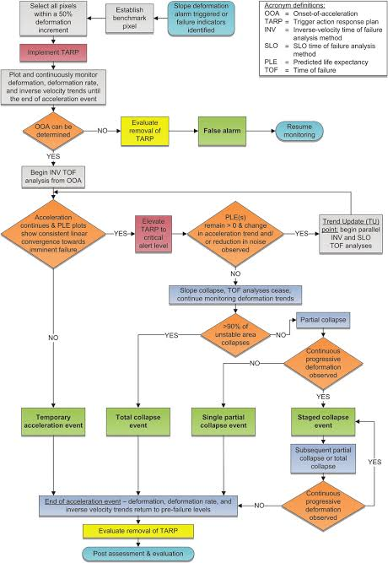

**6. Result:**

It helps us to determine the average period that a person is expected to live including all the factors with effect the life expectancy are taken into consideration.

**7. Advantages and disadvantages:**

Advantages:

1. Helps to determine the strongest area effecting the life of people
2. Helps to determine the status of country

Disadvantages:

1. Individual life expectancy cannot be determined. only the overall life expectancy of the country can be determined

**8. Conclusion**:

The life expectancy of the country can be determined continuously.

**9. Future scope:**

It helps in the development of the country

**10. Bibliography:**

1. From smartinternz student workspace